SUPERSTORE SALES INTELLIGENCE PLATFORM
Week–1 Internship Project Report
Name: Mohit Kumar Rana
Internship: AI-ML Internship – Week 1. ( ReadyNestCorp. )
Project Duration: 15 June, 2026 - 20 June, 2026
Tools Used
- Python
- Jupyter Notebook
- Pandas
- NumPy
- Matplotlib
- Seaborn
- Plotly
- Power BI
- Git & GitHub

1. Project Overview
Objective
The objective of this project is to analyze Superstore sales data, identify business trends, evaluate product and customer performance, and develop an interactive analytical dashboard for decision-making.

2. Dataset Description
Dataset Name
Sample Superstore Dataset
Dataset Summary
Metric | Value
Records | 10,194
Features | 21
Time Period | 2014–2017
Missing Values | 0
Duplicates Removed | XX
Main Features
Order Date
Ship Date
Sales
Profit
Discount
Category
Sub-Category
Customer Segment
State
Region

3. Data Preparation
Cleaning Steps Performed
Checked missing values
Removed duplicate records
Standardized column names
Converted date columns
Created Month-Year feature
Verified data types
Feature Engineering
Month-Year
Profit Margin
Average Order Value
Sales per Customer

4. Exploratory Data Analysis
Descriptive Statistics – ( Mean Sales , Median Sales , Standard Deviation , Profit Distribution )

Univariate Analysis
Histogram of Sales , Histogram of Profit , Category Distribution ,Customer Segment Distribution
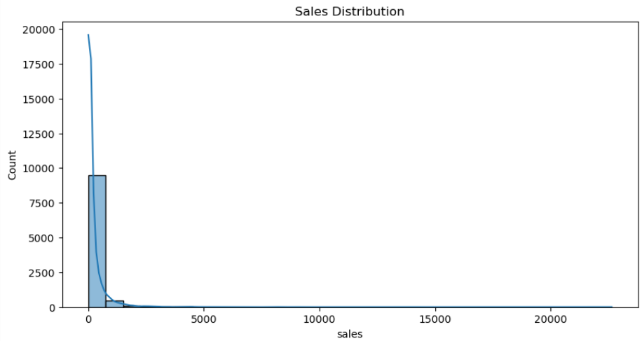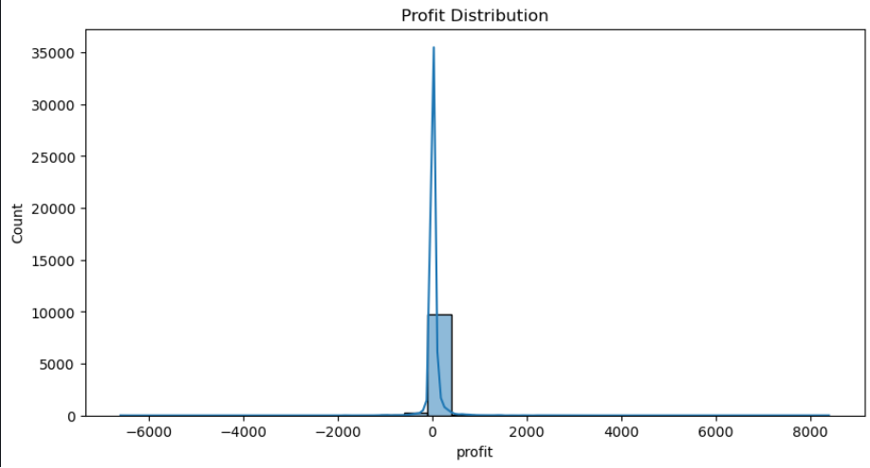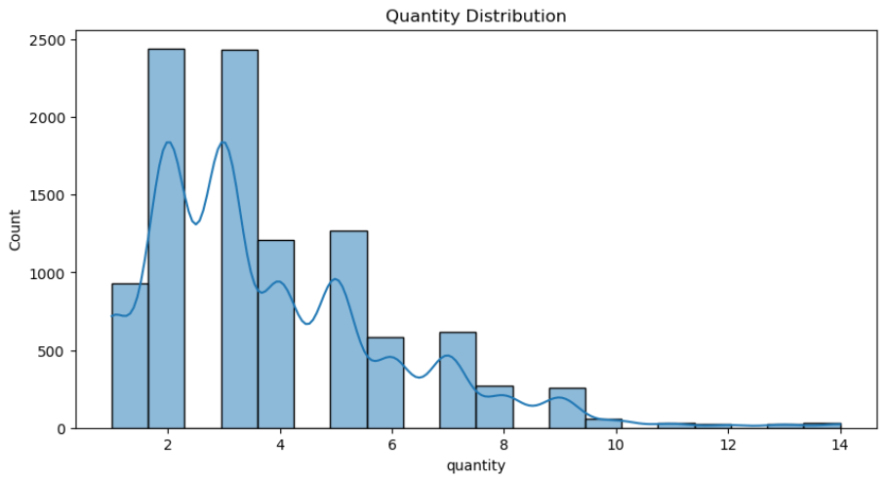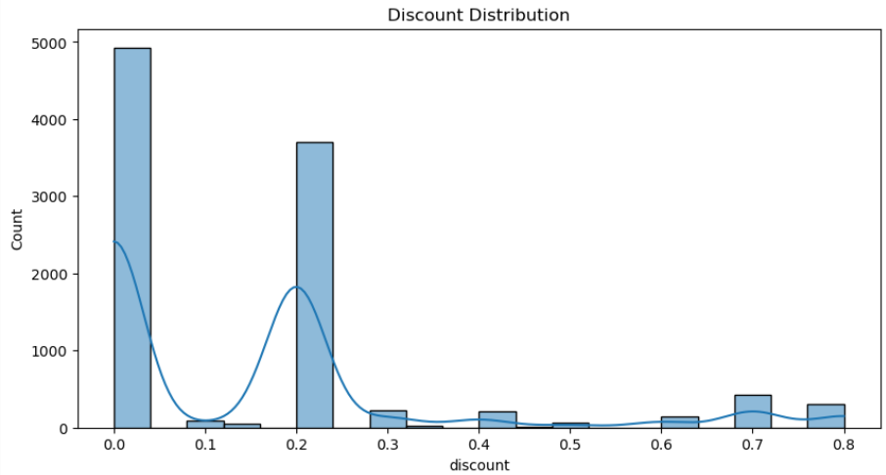
Bivariate Analysis
Sales vs Profit
Discount vs Profit
Category vs Sales
Region vs Profit
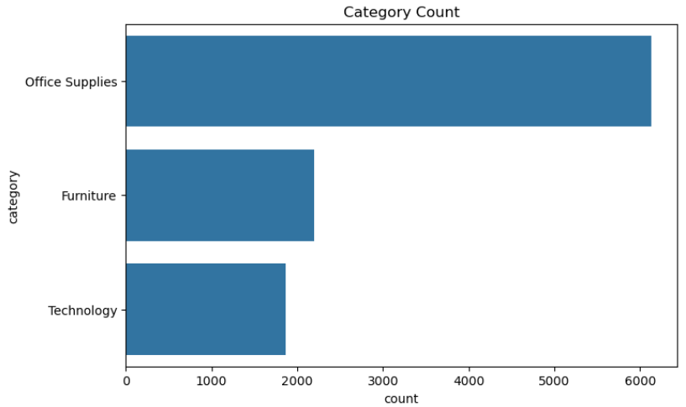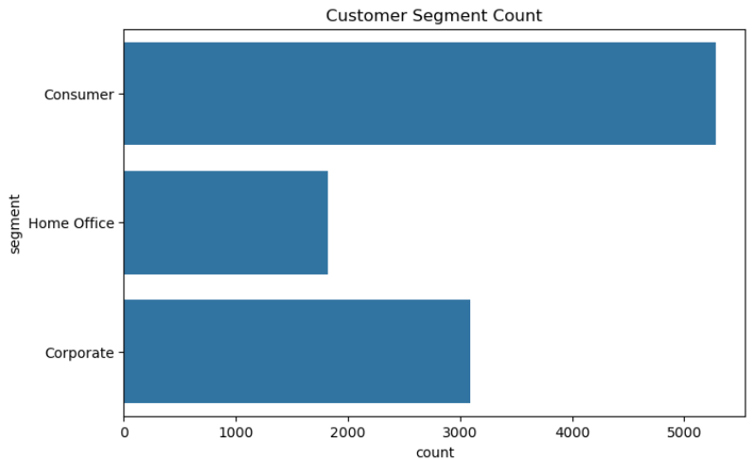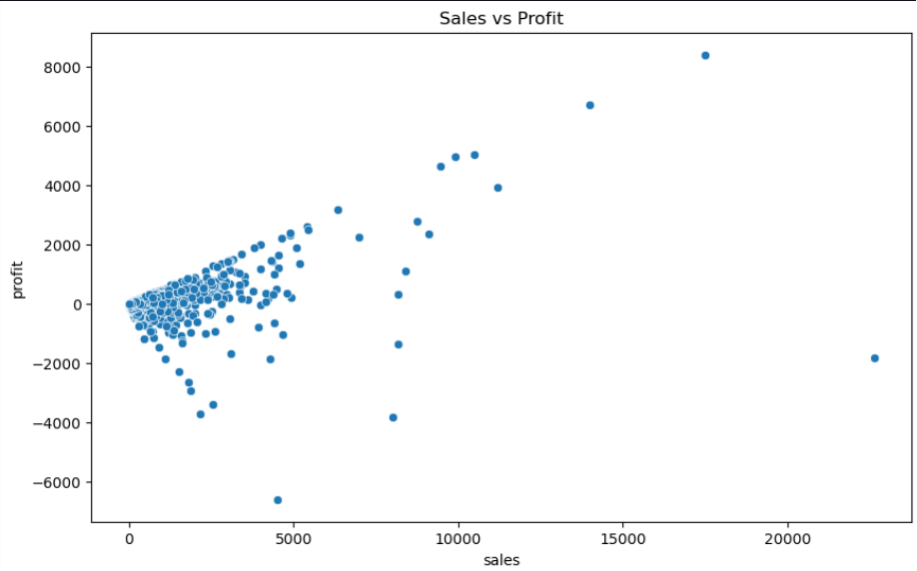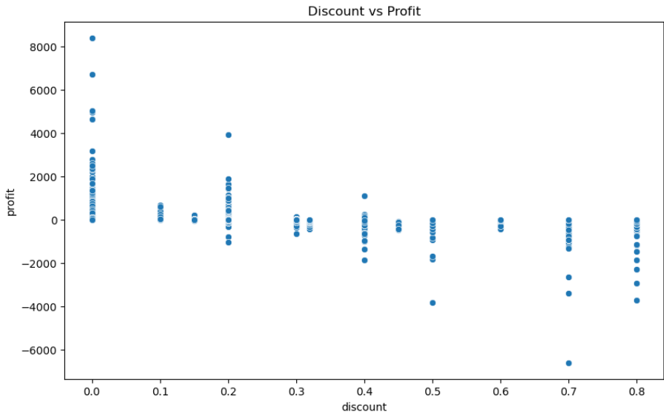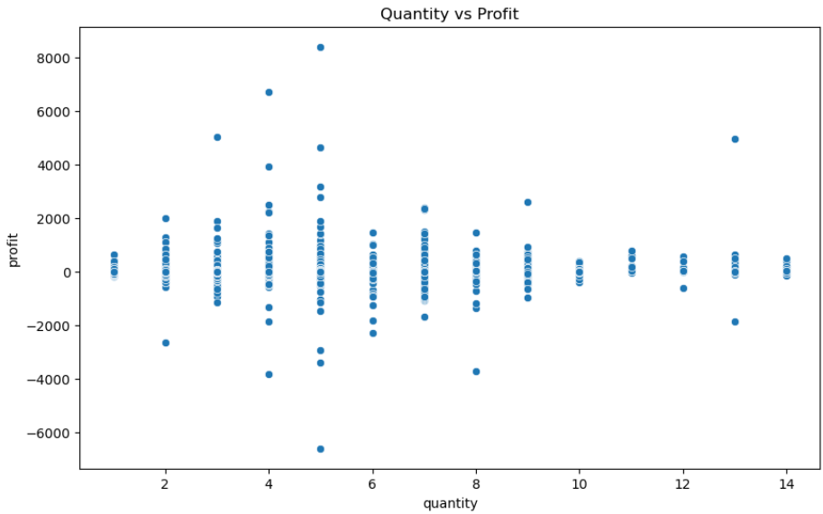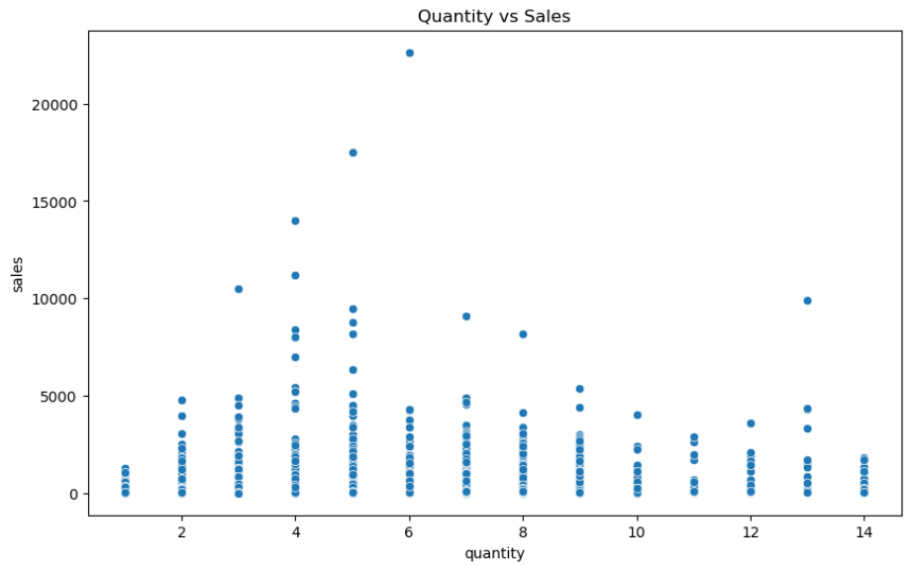

Correlation Analysis
Heatmap showing relationships between:
Sales
Quantity
Profit
Discount
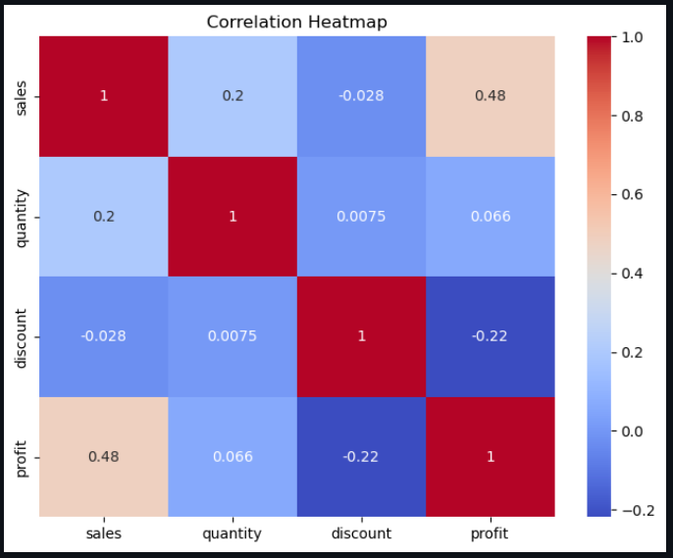
5. Geographic Analysis
Sales by State
Profit by State
Regional Comparison
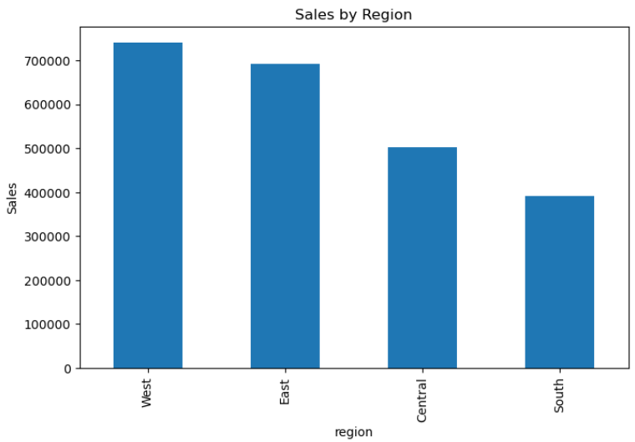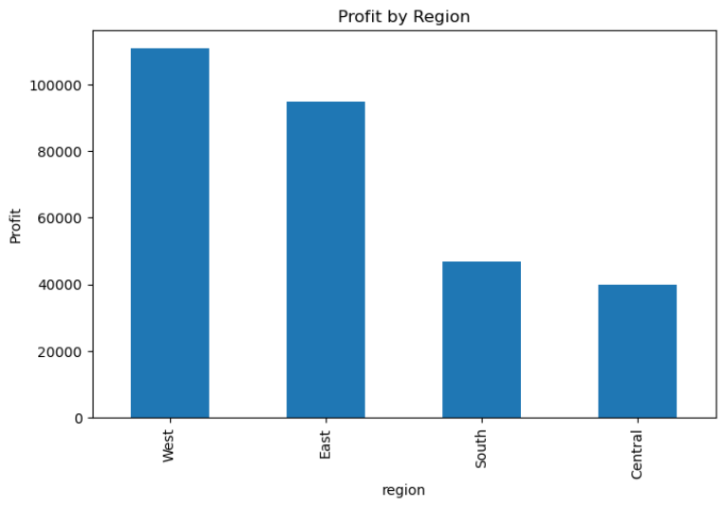
6. Power BI Dashboard
Pages Developed
Page 1
Executive Overview
KPIs
Total Sales
Profit
Orders
Customers
Page 2
Sales Analysis
Monthly Trend
Moving Average
YoY Comparison
Page 3
Customer Analytics
Customer Segment Analysis
Top Customers
Page 4
Product Analytics
Treemap
Pareto Analysis
ABC Classification
Page 5
Geographic Dashboard
Map Visualization
Regional Filters
Page 6
Forecasting
30-Day Forecast , 90-Day Forecast

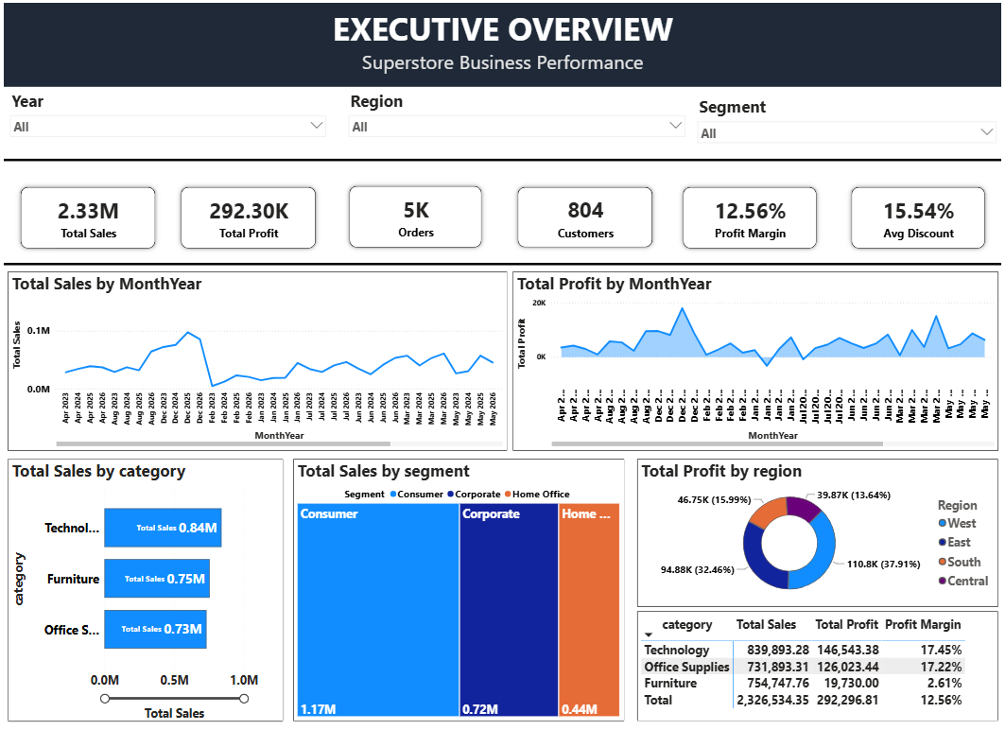
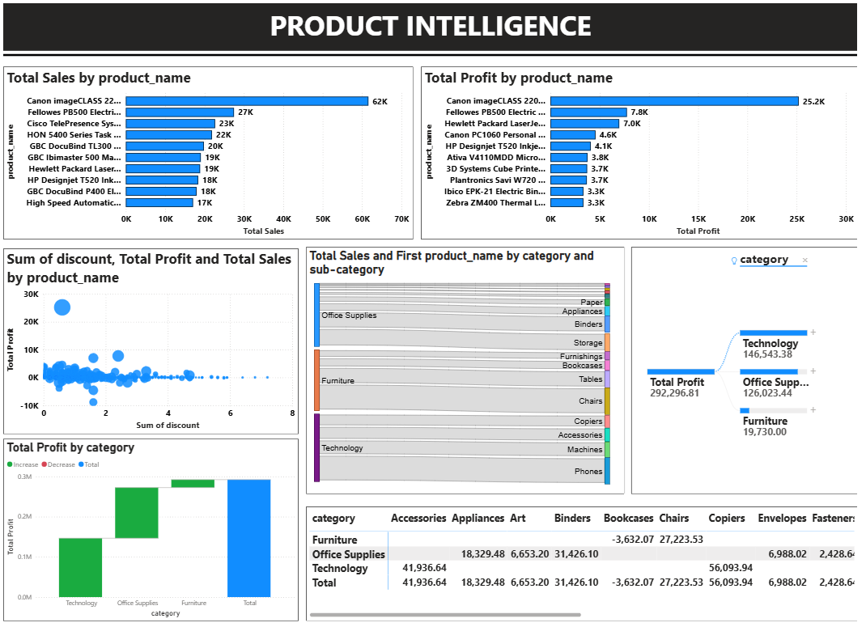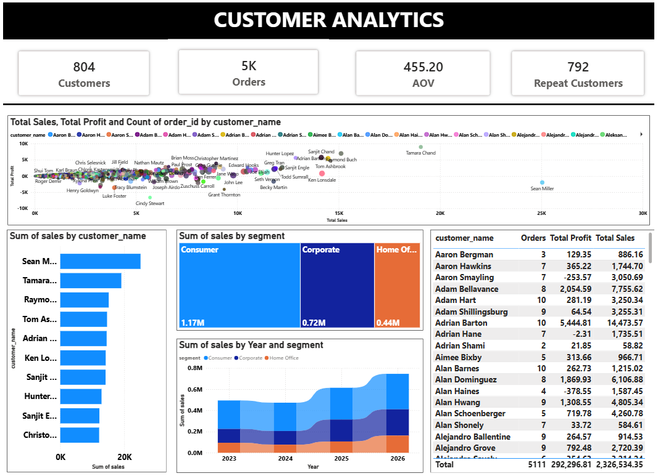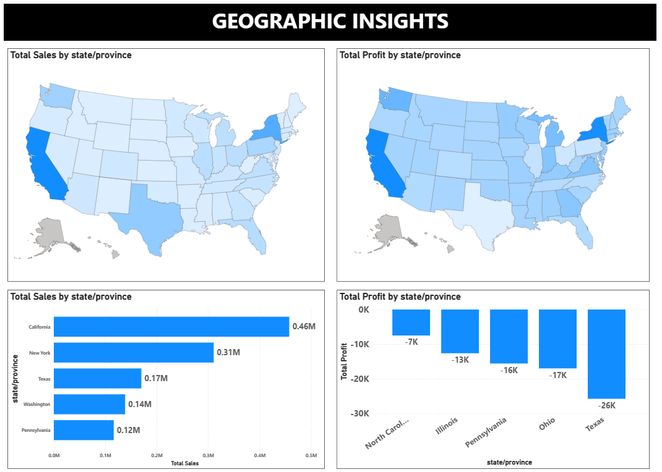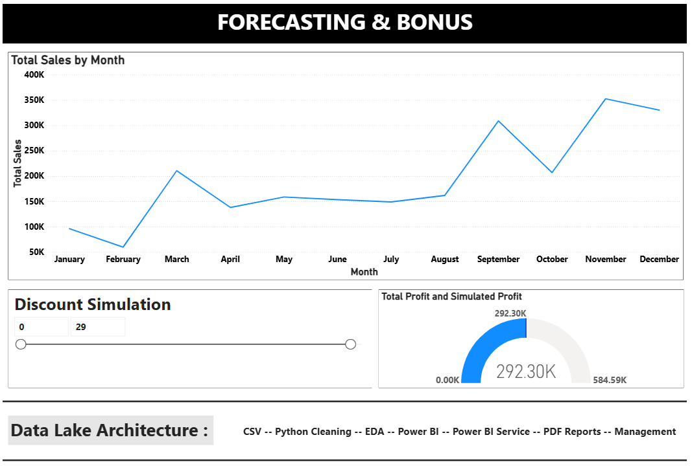
7. Business Insights
Insight 1
Technology category generated the highest sales volume.
Insight 2
Furniture products exhibit lower profit margins.
Insight 3
California contributes the highest revenue.
Insight 4
Discounts above 20 percent negatively affect profitability.
Insight 5
Standard Class shipping dominates order volume.

8. Recommendations
Reduce discounts on low-margin products.
Increase inventory for high-performing categories.
Focus marketing efforts on profitable states.
Investigate loss-making products.
Implement customer retention strategies.

9. Future Scope
Customer Segmentation
RFM Analysis
Cohort Analysis
Predictive Modeling
Market Basket Analysis
Interactive Web Application
Machine Learning Forecasting

10. Repository Structure
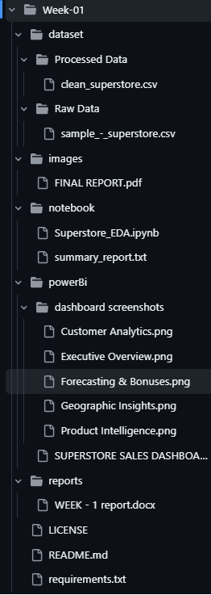
Conclusion
This project demonstrates an end-to-end analytics workflow including data preprocessing, exploratory analysis, business insight generation, dashboard development, and forecasting.
The implementation follows industry-standard practices for reproducibility, documentation, and portfolio presentation, making it suitable for internship evaluation and future recruiter assessment.

